**H01 Lab Sheet**

**Name __________________________ Date ______________**

**Lesson 1: Basic Electronics and Circuits Design Controller Programming**

1. **Give 3 examples of basic types of C++ variables.**

_________________________________________________________________________________________________________________________________________________________________________________________________________

1. **Please Identify which of these circuits is a serial circuit and parallel circuit**.

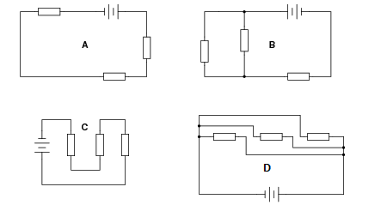

_________________________________________________________________________________________________________________________________________________________________________________________________________

1. **Can you roughly draw analog and digital signals?**

**Analog Signal:**

**Digital Signal:**

1. **What is the range of analog reading of the potentiometer in Arduino?** Hints: Try to use different voltages as input.

_________________________________________________________________________________________________________________________________________________________________________________________________________

1. **How can we convert the analog output of a potentiometer to a range between 0 and 100?**

_________________________________________________________________________________________________________________________________________________________________________________________________________